Table of Contents
Step 0 Intake + Interview Filing Status, Dependency 2
Step 1 Basic Information 3
Step 1a Filing Status 3
Step 1b Personal Information 3
Step 1c New Jersey Return 3
Step 1d Dependents or Qualifying Person(s) 3
Step 2 W-2 4
Step 3 1099-R 5
Step 3a Form 1099-R 5
Step 3b Form 1099-R Distribution Penalty 5
Step 4 Self Employment 6
Step 4a 1099-MISC 6
Step 4b Sch C – Basic Information 7
Step 4c Sch C – Questions About the Operation of Your Business 7
Step 4d Sch C – Income 7
Step 4e Sch C – Car And Truck Expenses 7
Step 4f Sch C – Other Expenses 8
Step 5 1099-C Cancellation of Debt (Credit Card) 9
Step 6 Unemployment 10
Step 7 Alimony Paid 10
Step 8 IRA Contribution 10
Step 9 Student Loan Interest 11
Step 10 Sch A Deductions 11
Step 10a Sch A Medical 11
Step 10b Sch C Health Insurance 12
Step 11 5329 12
Step 12 Child Care Credit 12
Step 13 Health Insurance 12
State Section (New Jersey) 13
Step 14a NJ Checklist – Basic Information 13
Step 14b NJ Checklist – Income Subject to Tax 13
Step 14c NJ Checklist – Subtractions from Income 13
Step 14d NJ Checklist – Credits 13
Step 14e NJ Checklist – Tax 13
Step 14f NJ Checklist – Payments 13
Step 14g NJ Checklist – Miscellaneous Forms 13
e-File Section 14
Step 15a E-File – Return Type 14
Step 15b E-File – Tax Preparation and E-File Information 14
Step 15c E-File – State Return(s) 14
Step 15d E-File – Taxpayer Bank Account Information 14
Step 15e E-File – Third Party Designee Info 14
Step 15f E-File – Consent to Disclose Tax Return Information … 14
Step 15g E-File – Questions 15
Step 15h E-File – State ID (Optional) 15
Step 15i E-File – Submission 15

Step 0 Intake + Interview Filing Status, Dependency
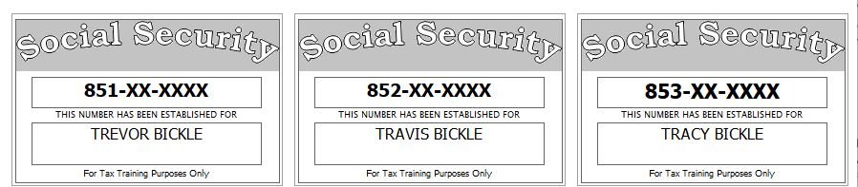
Before starting the return in TSO, you examine SS cards and picture id, review and correct the Intake Sheet, examine the prior year return, and examine and sort all tax documents. You also ask probing questions to determine dependency status and the appropriate filing status.
You can start filling out the NJ Checklist any time.
Trevor’s divorce decree states that he must pay alimony, child support, and reimburse his ex for some of her expenses. The decree also says his ex gets to claim their daughter, Tracy, as a dependent on her return even though Trevor provides majority support for both Travis and Tracy. Trevor has provided his ex a signed form 8332 to facilitate this.
Trevor had health insurance (which meets ACA MEC standards) for himself and the two children living with him
Notes from examination of prior year return:
- Trevor did not itemize last year
- Trevor owed (and paid) tax due last year of $545 on his federal return and $287 on his NJ return
Extra interview information for NJ:
- Contribution to the Gubernatorial Election Campaign Fund should be handled the same as his contribution to the Presidential Election Campaign Fund.
- Trevor rented his primary residence (700/mo for Jan-Jun and 800/mo for Jul-Dec)
- Any NJ refund or amount owed should be handled the same as the Federal
- Trevor is not a veteran
Reference: 4012 Tab A, B, C
Tool: IRS Interactive Tax Assistant (link on Preparer page)
Tool: AARP Resource Tool for Counselors (Laminated Flow Chart)
Tool: TP4F Qualifying Child/Qualifying Relative Flowchart Tool (link on Preparer page)
Tool: Dependent Calculator (link on Preparer page)

Step 1 Basic Information
Enter Trevor’s SSN to start the return

Step 1a Filing Status
Use the Filing Status you figured out as part of Step 0

Step 1b Personal Information
Use Intake Sheet and interview notes

Step 1c New Jersey Return
Answer “NO” to “Do you meet Property Tax Credit or Deduction Eligibility Requirements?” (even if you know that the requirements are met – we will deal with this later in the NJ section).
Answer “YES” to “Does the Taxpayer have Health Insurance?”.
On the next screen, answer the Municipality question then Click “CONTINUE” before answering any other questions on this screen.
Tool: NJ Municipality Code Lookup Tool (link on Preparer page)
Tool: NJ 1040 Instructions – Municipality Code Table

Step 1d Dependents or Qualifying Person(s)
Enter information for dependents.
Hint: Do not go to the State Section and do anything until you are done with the Federal Section and Health Insurance sections. Use the NJ Checklist to record things you will need to remember when doing the State Section later.
Federal AGI: 0 Federal Refund: 0 NJ Refund: 0

Step 2 W-2
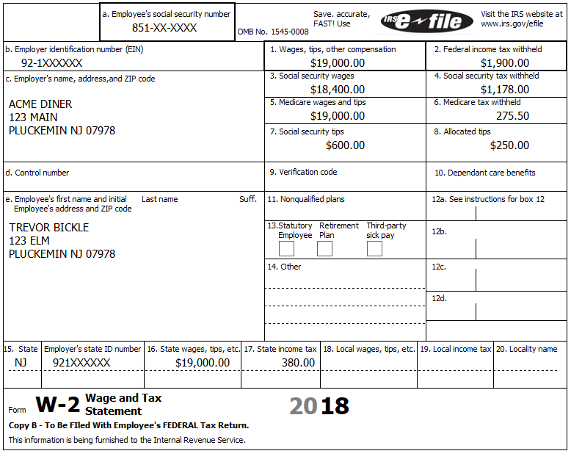
72.68 UI
8.08 WF/SWF
36.10 DI
17.10 FLI
Reference: 4012 D-4 to D-6
Hint: TSO may complain about the Social security tax in box 4 – Verify that your numbers match the form – if so, you can ignore this annoying complaint.
Federal AGI: 19,250 Federal Refund: 8,866 NJ Refund: 2,447
Q: Why is the refund amount (Federal and NJ) so much more than the withholding amount?

Step 3 1099-R
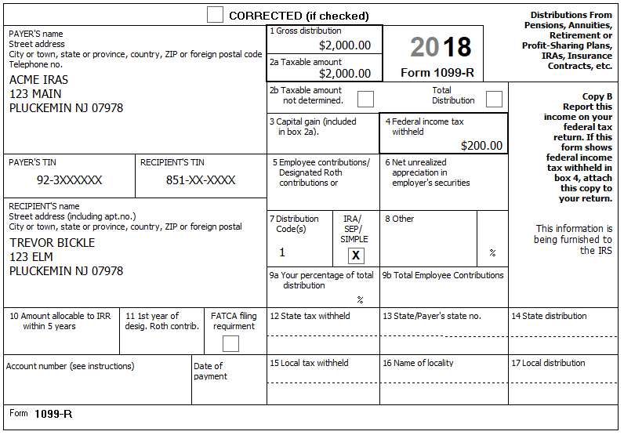
During the summer, Trevor took an IRA distribution to pay off some unexpected medical costs.
Reference: 4012 D-37 to D-39

Step 3a Form 1099-R
Federal AGI: 21,250 Federal Refund: 8,645 NJ Refund: 2,028

Step 3b Form 1099-R Distribution Penalty
Hint: After clicking CONTINUE on the 1099-R screen you get a supplemental screen with a couple of questions relating to the penalty for an early distribution (box 7, code 1). You must answer the questions and click CONTINUE again before the penalty will be included in the Federal Refund calculations.
Hint: We want to be able to use the Medical exemption on form 5329 to minimize the penalty associated with this early withdrawal, but the amount of the exemption we can claim depends on the AGI. As a result, we will wait to enter the 5329 until the AGI is finalized.
Federal AGI: 21,250 Federal Refund: 8,445 NJ Refund: 2,028

Step 4 Self Employment
Trevor drives for Acme RideShare.
Reference: TaxPrep4Free RideShare Training page (link in All Preparers section of the Student page). The For-Hire Drivers presentation is good for those new to this topic.
Hint: We can start by either creating the Sch C or by entering the 1099-MISC directly. We’re going to start by entering the first 1099-MISC directly (Federal > Income > Form 1099-Misc)

Step 4a 1099-MISC
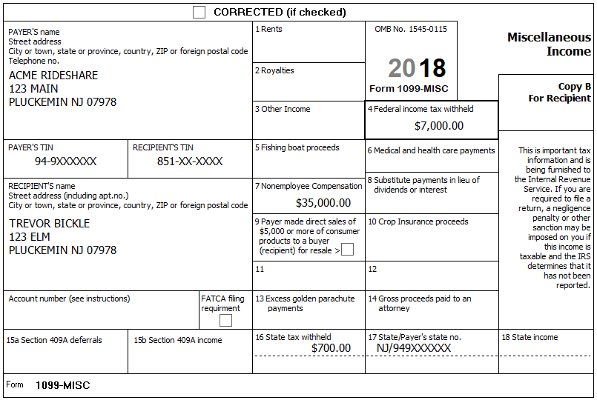
Federal AGI: 21,250 Federal Refund: 15,445 NJ Refund: 2,728
Hint: This is our first 1099-MISC, so after clicking Continue, then click “Create a New Schedule C Income from Business” on the “Where would you like to add the income?” screen. See next sub-step for help filling in the Basic Information for the Sch C
Federal AGI: 53,777 Federal Refund: 1,914 NJ Refund: 183

Step 4b Sch C – Basic Information
He had no separate business name, no EIN, and no business address (other than his home).
Tool: NAICS Search Tool (link on Preparer page)
Tool: 1040 Instructions, Sch C Business Codes table
Hint: You probably won’t have much luck looking for the business code – use 485990.
Federal AGI: 53,777 Federal Refund: 2,694 NJ Refund: 183

Step 4c Sch C – Questions About the Operation of Your Business
Click on “Questions About the Operation of Your Business” on the Schedule C menu.
He uses the Cash Accounting Method. He has no inventory. This is not the first Sch C for this business. He does all the work for the business himself. There is no prior year unallowed loss. He made no payments that would require him to file Form(s) 1099. This is not a Qualified Joint Venture
Federal AGI: 53,777 Federal Refund: 2,694 NJ Refund: 183

Step 4d Sch C – Income
Click on “Income” on the Schedule C menu.
In addition to the 1099-MISC (above), he received a 1099-K showing $18,000 for credit card charges. He also received cash tips of $2,000.
BP: Use the Itemized Amounts button to record details
Federal AGI: 72,364 Federal Refund: -1,914 NJ Refund: -348

Step 4e Sch C – Car And Truck Expenses
Click on “Car And Truck Expenses” on the Schedule C menu.
Trevor has a 2016 BMW Model 7L which he bought in 2016 and began using for business on 08-01-2017.
The statement from Acme RideShare shows 20,000 miles driven while transporting customers.
Trevor’s mileage app shows 5,000 miles between rides and 1,000 miles driven between his home and his first and last customer of the day. (He is not claiming the (out-of-scope) home office deduction.)
The total mileage on his car for the year was 50,000.
He does not have another vehicle available for personal use. This vehicle was available for personal use during off hours. He has a written record of his business mileage.
Q: How many “Other” miles should he report?
Hint: See 4012 D20 for suggestion of what to use for “Description of Vehicle”
Federal AGI: 59,702 Federal Refund: 1,223 NJ Refund: 27

Step 4f Sch C – Other Expenses
Click on “Other Expenses” on the Schedule C menu.
Trevor kept a detailed record of his expenses. Trevor has chosen to allocate the business portion of any amounts that are part business and part personal based on the percentage of business miles to total miles. Some expenses listed may not be allowed at all.
- $150 for business cards
- $600 for car cleaning & detailing
- $200 for tolls (all business related)
- $1,800 for various expenses (on statement from Acme RideShare)
- $800 for normal auto insurance (collision, etc.)
- $250 for special liability insurance as a rideshare driver
- $1,200 interest on the auto loan for the car
- $1,250 for meals while waiting for customers
- $20 for bottled water for passengers
- $11,400 for car repairs
- $1,200 for separate business cell phone and service
Federal AGI: 55,780 Federal Refund: 2,197 NJ Refund: 130
Check: Federal Sch 1, line 12 (Business income or (loss)) should be 37,155 (Also on Sch C, line 31 (Business income or (loss)))

Step 5 1099-C Cancellation of Debt (Credit Card)
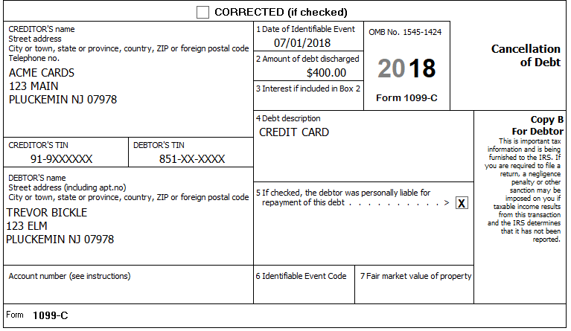
Travis had a hard time making ends meet during the spring. As a result, he got behind on his credit card and ended up making a deal with the company to forgive $400 of the amount he owed. As a result, he got a 1099-C. (Trevor is not insolvent.)
Federal AGI: 56,180 Federal Refund: 2,149 NJ Refund: 130

Step 6 Unemployment
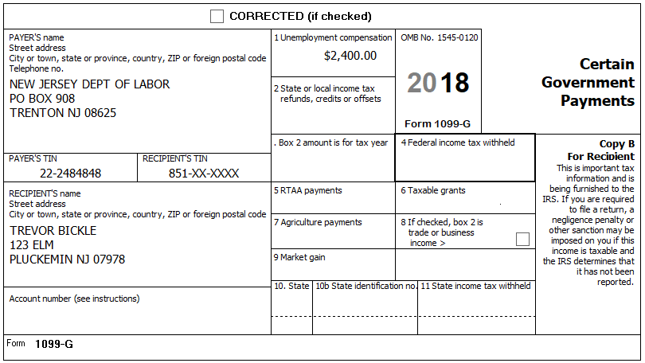
Q: If Trevor’s unemployment was from another state, would either Federal or NJ change?
Federal AGI: 58,580 Federal Refund: 1,861 NJ Refund: 130

Step 7 Alimony Paid
Trevor’s divorce decree states that he is to pay $400 ($300 for alimony plus $100 for child support) per month to his ex (SSN 854-XX-XXXX). (There is another child who lives with the ex.)
All child support payments were made on time, but he was late on three alimony payments during the spring and missed two other alimony payments entirely.
In addition, he is required by the decree to reimburse his ex for certain expenses – this year these reimbursements totaled $967.
Federal AGI: 54,613 Federal Refund: 2,335 NJ Refund: 228

Step 8 IRA Contribution
Trevor made a $1,000 contribution to his regular IRA for the current tax year in January of the year after the current tax year. He has no retirement plan.
Federal AGI: 53,613 Federal Refund: 2,455 NJ Refund: 228

Step 9 Student Loan Interest
Trevor has a letter from his lender stating that he paid $2,700 in student loan interest this year.
Federal AGI: 51,113 Federal Refund: 2,725 NJ Refund: 228
Q: Interest amount is $2,700, but AGI only went down by $2,500 – why?

Step 10 Sch A Deductions
Hint: Do NOT enter anything yet, we will handle entry in the following sub-steps.
Trevor has a list of the following potential deductions:
- Medical for Trevor and the two kids living with Trevor:
  - $2,200 for medical insurance (Trevor & Travis only)
  - $800 for dental insurance (Trevor & Travis only)
  - $3,250 to doctors/dentists for co-pays and deductibles
    - $2,500 for Trevor; $400 for Travis; $350 for Tracy)
  - $2,750 for unreimbursed prescriptions
    - $2,700 for Trevor; $50 for Travis; $0 for Tracy)
  - 600 medical miles
- Trevor owed (and paid) tax due last year of $545 on his federal return and $287 on his NJ return
- $160 of charitable cash donations (with cancelled checks)
- $240 for donation of clothes (with receipts and fair values)
- $40 for safe deposit box for financial papers
Q: Can you look at the above list and tell immediately whether Trevor would have enough itemized deductions to exceed his standard deduction? (Except for the above, he has no deductible property tax, mortgage, or other expenses)
Q: Which deductions should be entered even if using the standard deduction and which can be ignored if not itemizing? Why?
Q: The divorce decree allows Trevor’s ex to claim Tracy as a dependent – Can Trevor still deduct medical expense for Tracy?
Q: In general, what are the trade-offs of putting health insurance on Sch A vs expensing on Sch C? Is there an advantage for either approach with respect to the NJ return?

Step 10a Sch A Medical
Hint: Do not enter health insurance on Sch A - Trevor has self-employment, so he can expense his insurance costs even if he is not itemizing – this will be done in the next sub-step
Hint: Sch A health insurance and Sch C health insurance both flow to NJ.
Hint: Tracy is not a dependent – Don’t forget to add her amount to the NJ Checklist.
Federal AGI: 51,113 Federal Refund: 2,725 NJ Refund: 328

Step 10b Sch C Health Insurance
BP: TSO has a section under Deductions > Adjustments called “Self-Employed Health Insurance” – Do not use this option. Best practice is to put any SEHI on Sch C -> General Expenses > Health Insurance instead.
Federal AGI: 48,113 Federal Refund: 3,013 NJ Refund: 380

Step 11 5329
Trevor’s AGI will not change from this point forward, so we can now enter 5329 information relating to the early withdrawal from his IRA.
Hint: Only medical expenses above 7.5% (10% in TY2019) of AGI can be used to offset early distributions – See ScratchPad for calculation that we have sufficient medical to offset entire early withdrawal amount.
Reference: 4012 H-4 and H-4.1
BP: Enter 5329 info after AGI is stabilized if using medical exemption.
Federal AGI: 48,113 Federal Refund: 3,213 NJ Refund: 380
Q: If allowable medical expenses only added up to $5,108, what amount would one enter on the 5329?

Step 12 Child Care Credit
Trevor paid the upstairs neighbor (Betsy Palantine – SSN 855-XX-XXXX) to watch the two kids while he was at work. He paid $100 per month per child.
Reference: 4012 G-10 to G-13
Q: Travis is 13 and this credit is only allowed for children under 13 – why does Travis show up on the list of dependents? Tracy is a dependent on his ex’s return (per the divorce agreement) – why does Tracy show up on the list of dependents?
Hint: Payments are applicable to this credit on a monthly basis.
Hint: Because Trevor has earned income, you do not need to fill in anything on “F2441 – Child Care Credit – Page 2”.
Federal AGI: 48,113 Federal Refund: 3,573 NJ Refund: 452

Step 13 Health Insurance
The entire household had (non-Marketplace) MEC the whole year.
Note: TY2018 had a penalty for those without insurance or an approved exemption. This penalty was eliminated for TY2019. The potential subsidy for policies bought from the marketplace still applies.
Federal AGI: 48,113 Federal Refund: 3,573 NJ Refund: 452

State Section (New Jersey)
You have collected information during several Federal Steps on your NJ Checklist – It is now time to enter that information into TSO

Step 14a NJ Checklist – Basic Information
Federal AGI: 48,113 Federal Refund: 3,573 NJ Refund: 452

Step 14b NJ Checklist – Income Subject to Tax
Federal AGI: 48,113 Federal Refund: 3,573 NJ Refund: 452

Step 14c NJ Checklist – Subtractions from Income
Federal AGI: 48,113 Federal Refund: 3,573 NJ Refund: 446

Step 14d NJ Checklist – Credits
Trevor paid $700 per month rent for Jan-Jun and $800 per month for Jul-Dec
Federal AGI: 48,113 Federal Refund: 3,573 NJ Refund: 496

Step 14e NJ Checklist – Tax
Trevor did not make any purchases which would be subject to Use Tax.
Federal AGI: 48,113 Federal Refund: 3,573 NJ Refund: 496

Step 14f NJ Checklist – Payments
Federal AGI: 48,113 Federal Refund: 3,573 NJ Refund: 496

Step 14g NJ Checklist – Miscellaneous Forms
Federal AGI: 48,113 Federal Refund: 3,573 NJ Refund: 496

e-File Section
Collect any final information necessary…

Step 15a E-File – Return Type
Trevor has a Federal refund – he would like a direct deposit (per the Intake Sheet)
Hint: Federal Return Type = “E-file: Direct Deposit”

Step 15b E-File – Tax Preparation and E-File Information
Trevor’s email is given on the Intake Sheet

Step 15c E-File – State Return(s)
Trevor has a NJ refund – he would like a direct deposit (per Interview)
Hint: NJ Return Type = “E-file: Direct Deposit”

Step 15d E-File – Taxpayer Bank Account Information

Step 15e E-File – Third Party Designee Info
Hint: Do NOT fill in anything here.

Step 15f E-File – Consent to Disclose Tax Return Information …
Trevor agrees to GRANT consent. Enter any 5 digit PIN.

Step 15g E-File – Questions
“Was the taxpayer physically present during the entire return preparation and quality review process?” – answer Yes

Step 15h E-File – State ID (Optional)
Ignore this section
Hint: Click Save when done

Step 15i E-File – Submission
BP: Follow District / Site rules for what, if anything, you should do on this screen.

